Email: __________________________________ ____________________________________

Rev. 7-20

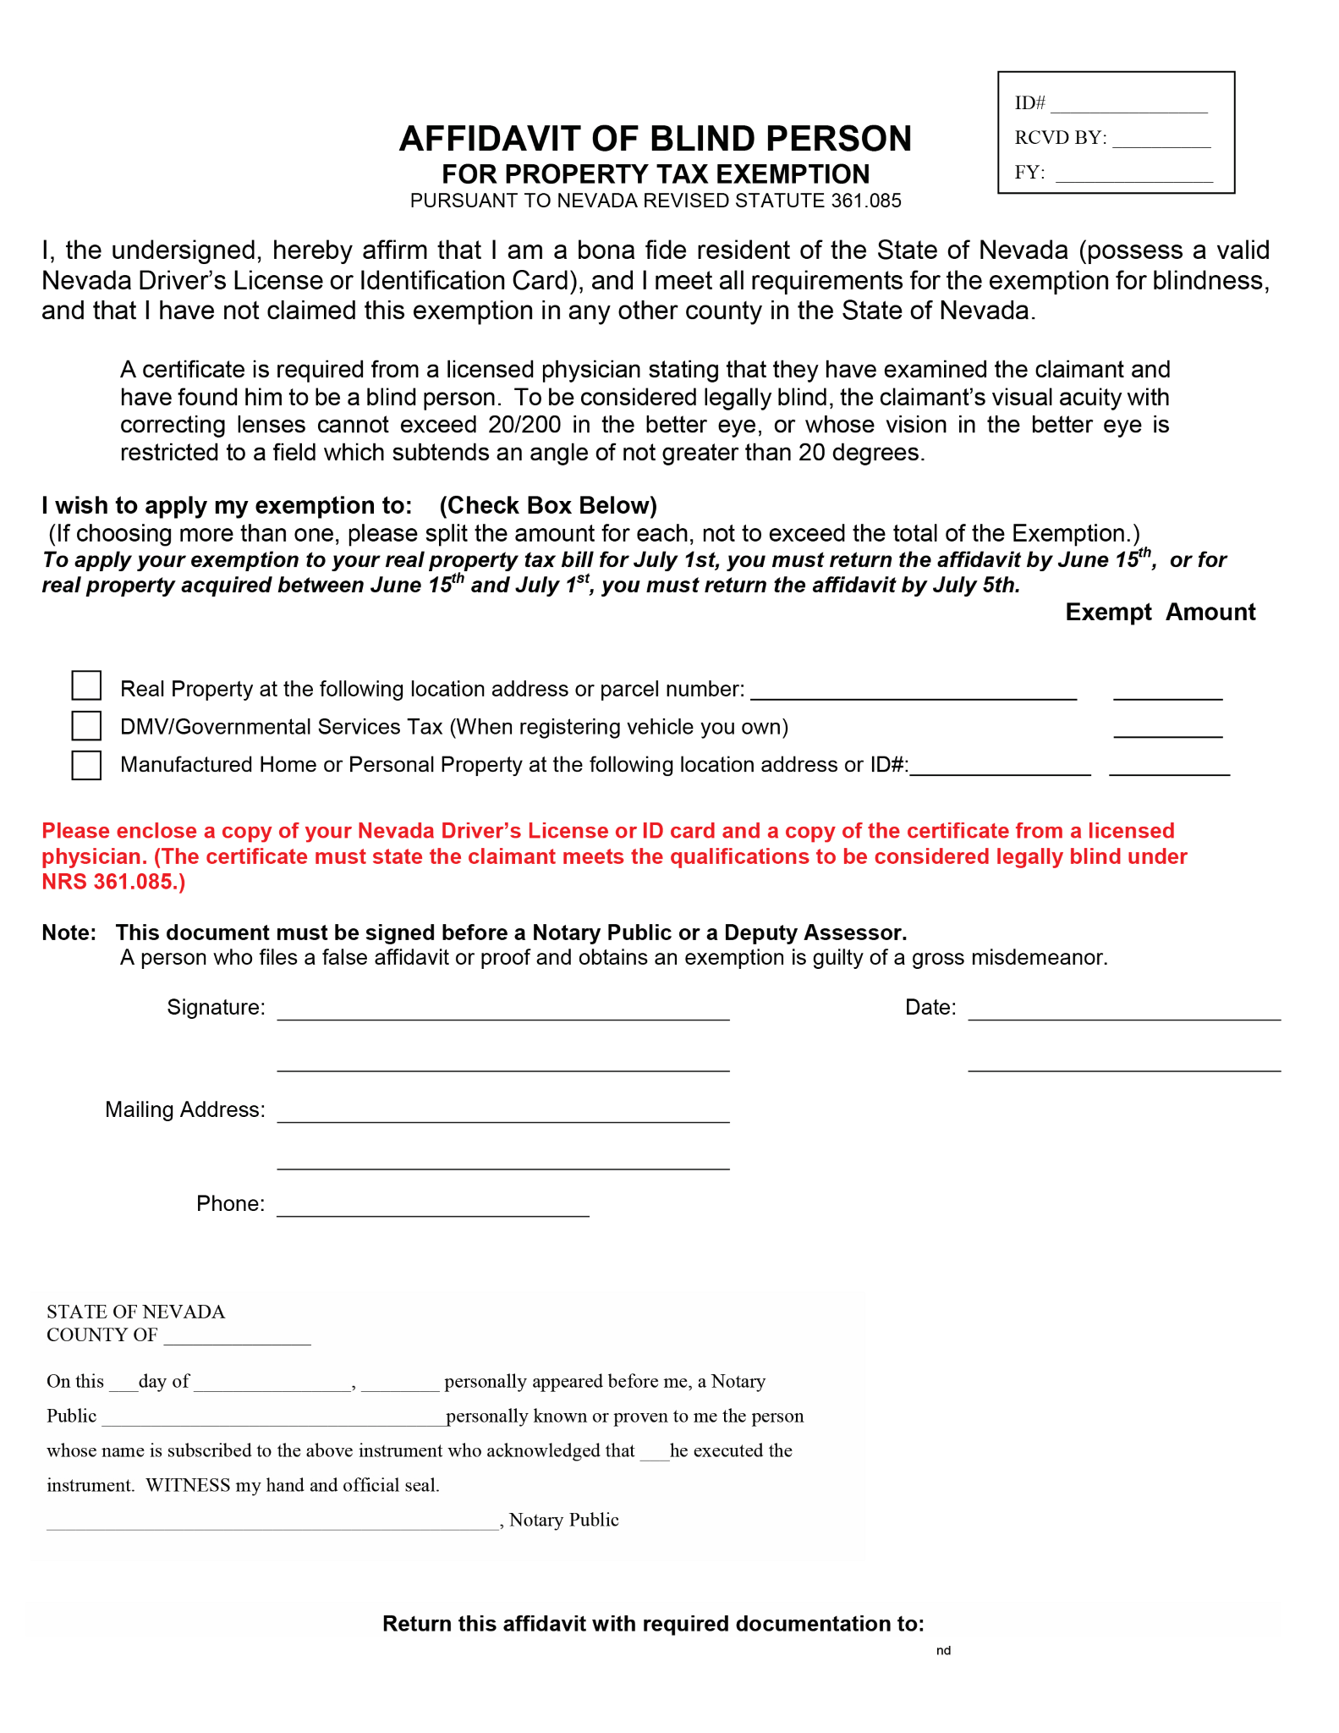

or email: AOCustomerServiceRequests@ClarkCountynv.gov